Silver State Volleyball Club Season
Silver State teams compete in the Northern California Volleyball Association (NCVA) Premier and Power League. This document will help explain how to find the location where your club team will be playing and their schedule. The location changes each tournament so it is important to check the schedule regularly.
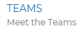
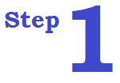
Check team schedule at SilverStateVolleyball.com
- Go to the team page tab at the top of page
- Select team and view schedule at bottom of page

- If listed at Premier League or Power League (PWL) follow steps below

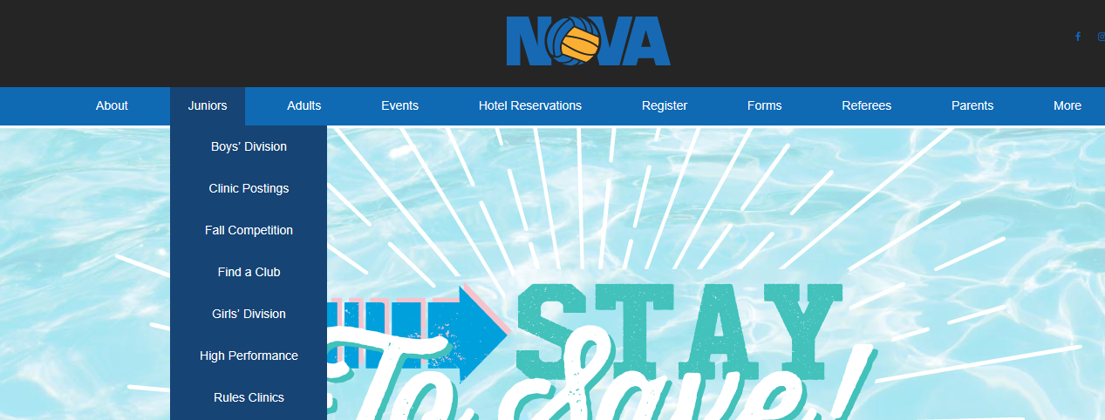

Go to NCVA.com (Northern California Volleyball Association)

- Go to “Juniors” tab
- Go to “Girls’ Division” tab


On the “Girls’ Division” webpage
- Select “Premier League”
- “Online Schedules by District” Sierra League
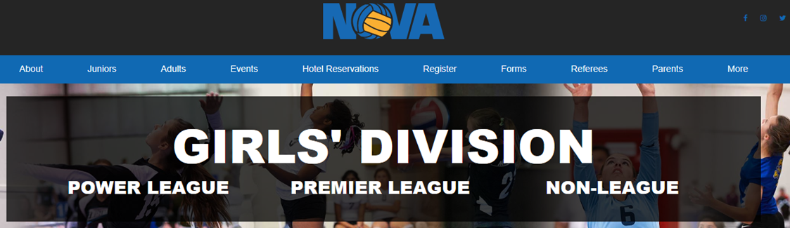
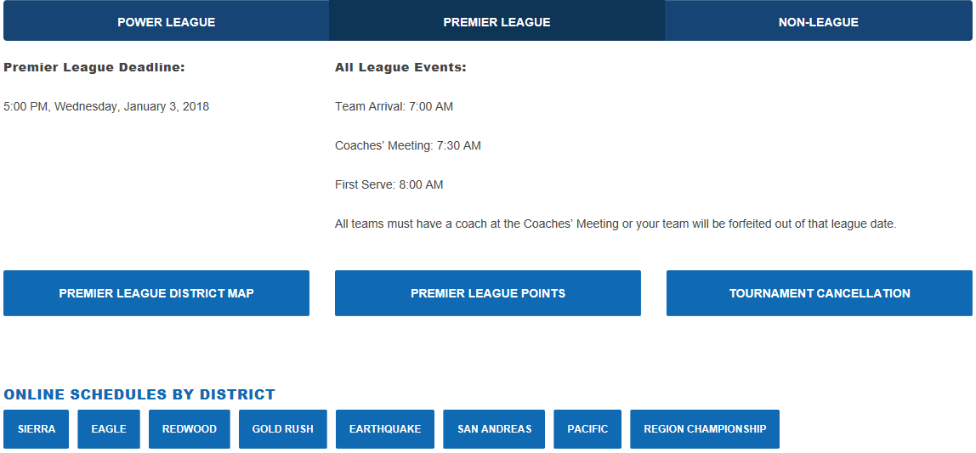
Select Premier League
Go to Sierra District
4

You will be taken to TM2Sign.com where you can choose the event, age group, and view location. Select the “Pool Charts” button and search for team and view schedule.
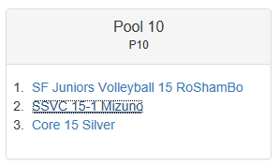

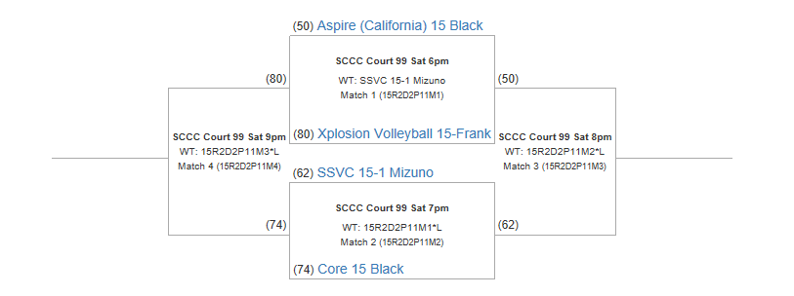
Location and court
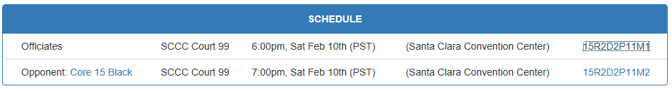
Schedule

